GNU Octave, version 3.8.2
Copyright (C) 2014 John W. Eaton and others.
This is free software; see the source code for copying conditions.
There is ABSOLUTELY NO WARRANTY; not even for MERCHANTABILITY or
FITNESS FOR A PARTICULAR PURPOSE. For details, type 'warranty'.

Octave was configured for "i586-pc-linux-gnu".

Additional information about Octave is available at http://www.octave.org.

Please contribute if you find this software useful.
For more information, visit http://www.octave.org/get-involved.html

Read http://www.octave.org/bugs.html to learn how to submit bug reports.
For information about changes from previous versions, type 'news'.

a = 1.000000
l = 1.000000
T = 0.050000

ε =
1.0000e-12

Параметры сетки:
n = 16
k = 8

hx = 0.062500
ht = 0.006250

Начальное возмущение =
@(x) 0.5 * x * (1 – x)

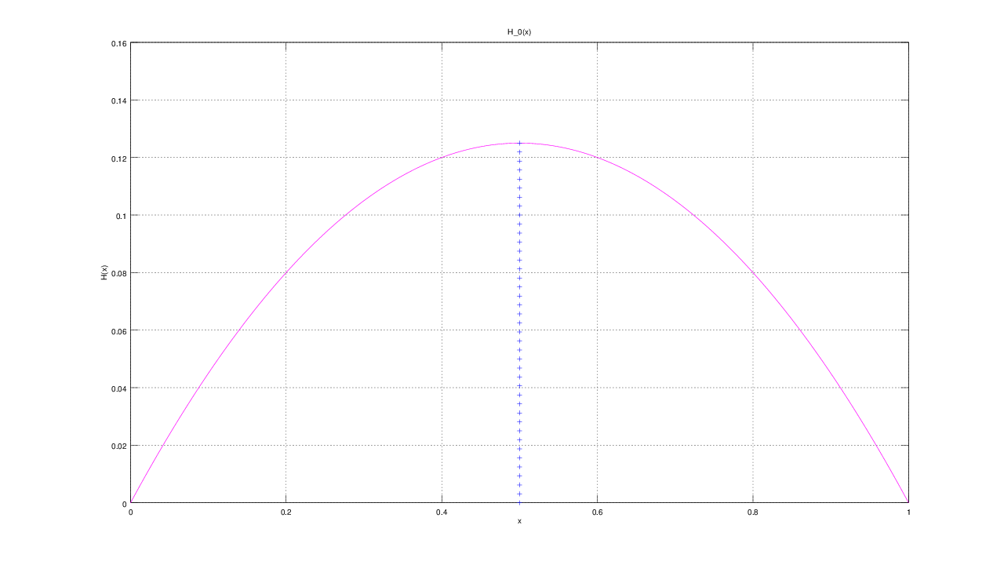

Всего демпферов: 1

Демпфер # 1

x_1 = 0.500000

Верхнее предельное значение w_1(t) =
NaN

Нижнее предельное значение w_1(t) =
NaN

Управляющая функция w_1(t):
91.842
-88.057
51.527
-15.984
-14.192
68.157
-89.385
182.954
-224.193

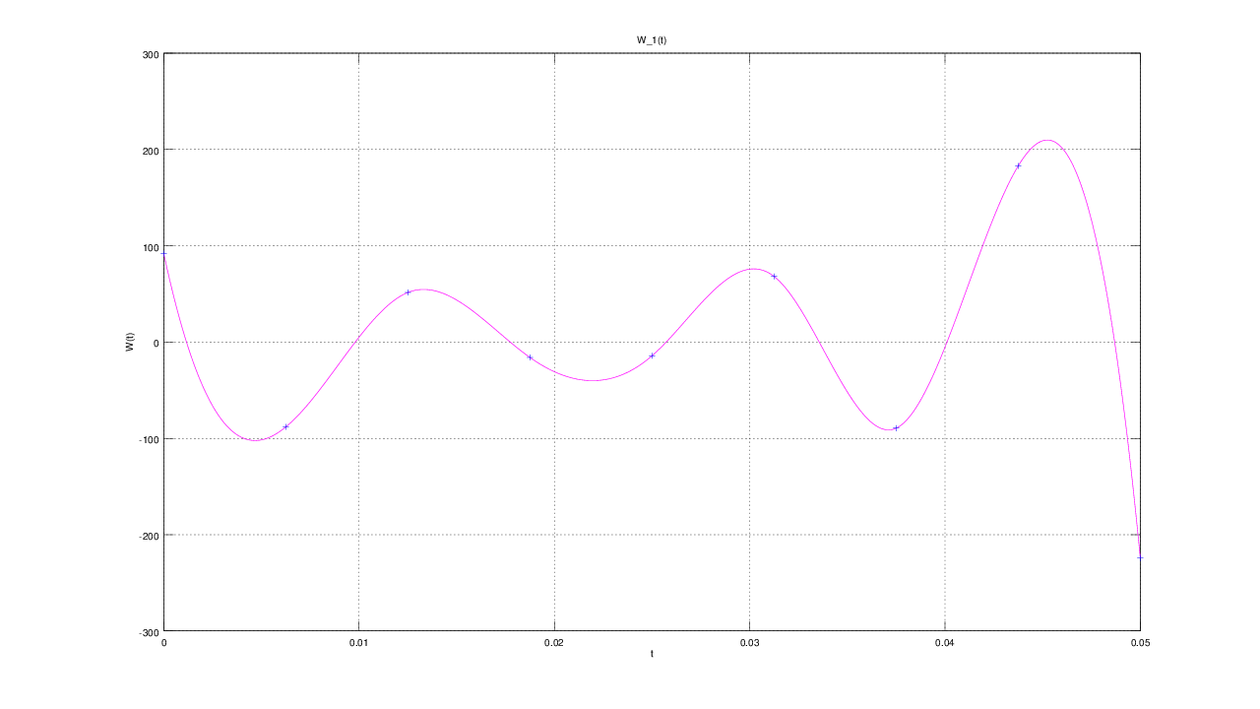

E(T) =
0.068395

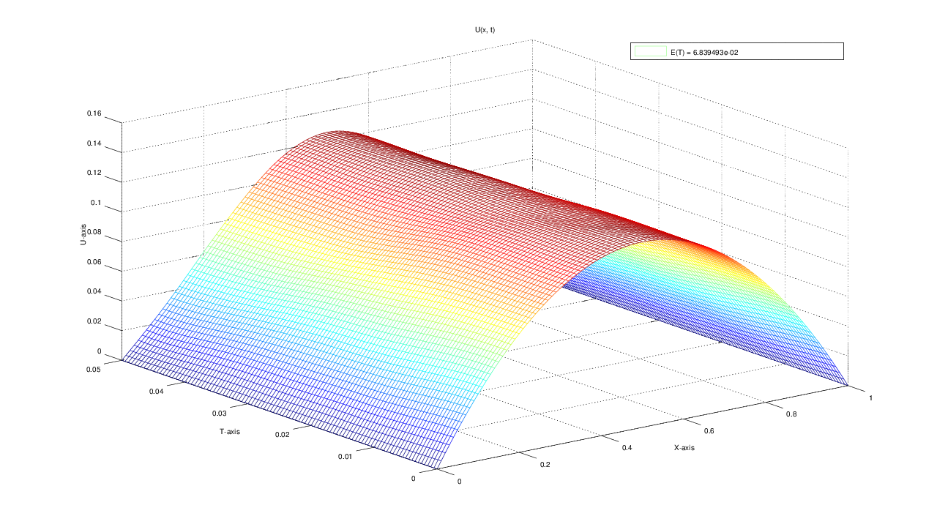

u(x, t)
T = 0.000000: 0.000000 0.029297 0.054688 0.076172 0.093750 0.107422 0.117188 0.123047 0.125000 0.123047 0.117188 0.107422 0.093750 0.076172 0.054688 0.029297 0.000000
T = 0.006250: 0.000000 0.027440 0.053490 0.075753 0.093704 0.107476 0.117270 0.123203 0.125266 0.123203 0.117270 0.107476 0.093704 0.075753 0.053490 0.027440 0.000000
T = 0.012500: 0.000000 0.025249 0.050314 0.073638 0.093010 0.107560 0.117285 0.122307 0.123110 0.122307 0.117285 0.107560 0.093010 0.073638 0.050314 0.025249 0.000000
T = 0.018750: 0.000000 0.024483 0.047756 0.070134 0.090399 0.106173 0.116261 0.121601 0.124163 0.121601 0.116261 0.106173 0.090399 0.070134 0.047756 0.024483 0.000000
T = 0.025000: 0.000000 0.023484 0.046534 0.067408 0.085992 0.101940 0.114479 0.122891 0.125220 0.122891 0.114479 0.101940 0.085992 0.067408 0.046534 0.023484 0.000000
T = 0.031250: 0.000000 0.022785 0.044447 0.064490 0.082041 0.098150 0.112827 0.123146 0.127423 0.123146 0.112827 0.098150 0.082041 0.064490 0.044447 0.022785 0.000000
T = 0.037500: 0.000000 0.021275 0.041434 0.060685 0.079808 0.097353 0.111694 0.122349 0.126776 0.122349 0.111694 0.097353 0.079808 0.060685 0.041434 0.021275 0.000000
T = 0.043750: 0.000000 0.018622 0.038319 0.058679 0.078682 0.097037 0.112108 0.122160 0.125922 0.122160 0.112108 0.097037 0.078682 0.058679 0.038319 0.018622 0.000000
T = 0.050000: 0.000000 0.017825 0.037067 0.057895 0.078207 0.096767 0.112183 0.122050 0.125626 0.122050 0.112183 0.096767 0.078207 0.057895 0.037067 0.017825 0.000000

